Ben Fredrickson

Learning Style Quiz

9/4/2024

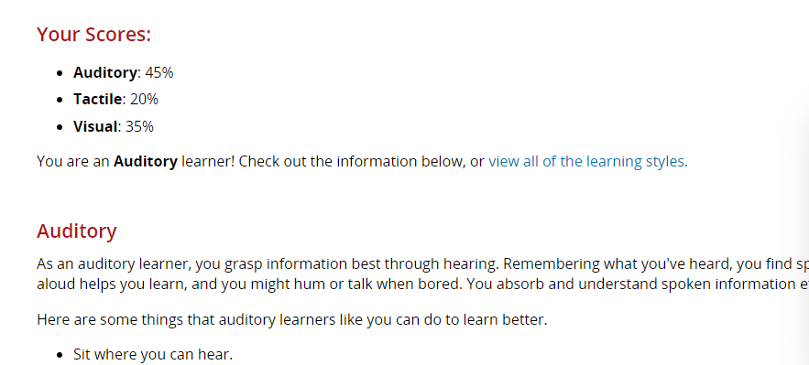

I was told from the quiz I am an auditory learner, which I mostly agree with. I also believe that I learn well doing something tactile. I do best with in person classes where I am able to interact with the teacher and class. I have found when studying for some of my big IT certification tests that listening to things on YouTube at double speed and testing myself has produced great results. I have also learned that I am pitifully bad with online classes. I have a hard time staying determined and dedicated to the class without any face to face interaction. I am a little bummed that I have multiple online classes this semester as they do not align with my learning style at all, I feel like I get little to nothing out of them.